LABORATORIO ARTIGIANO RETI
di ARCHETTI CARLO
Reti da Pesca – Sport – Caccia
Recinzione Impianti Sportivi
Antinfortunistica – Acquacoltura
25058 SULZANO (BS) – Via Tassano, n. 8
Tel. e Fax 030/985290 – Tel. Ab. 030/985191
Cell. 328 0562071 c.f. RCHCRL64C01F532U – P.I. 03216410179
www.retiarchetti.it – info@retiarchetti.it
www.retiarchetti.com – info@retiarchetti.com
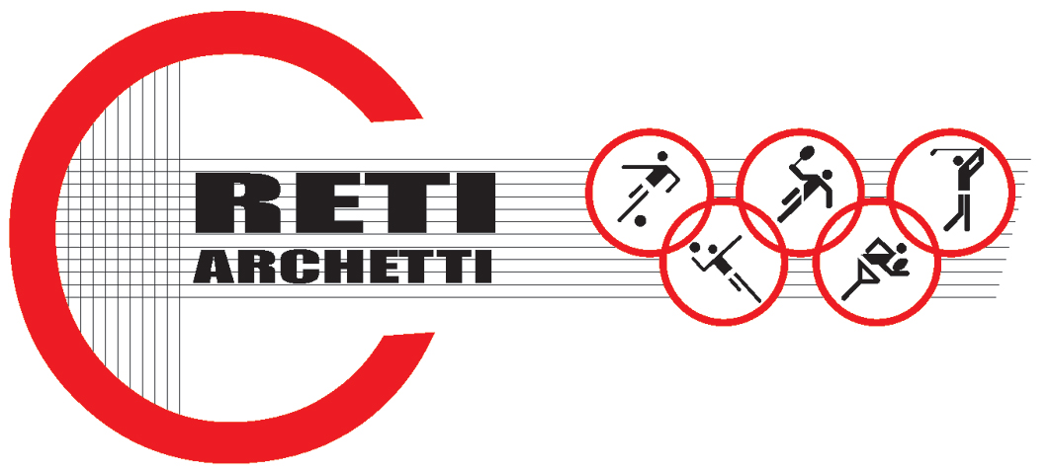

TECHNICAL DATA SHEET ART.CODE: A 44

NET MADE OF POLYETHYLENE, MESH mm 45 x 45, THICKNESS mm 5

STATIC TESTS: tests carried out on a 3D net, made of high resistant polyprophilene, stabilized against UV rays, without knot, green colored, (title 15000 denier, mesh mm 45 x 45) according to Standard EN 1263-1, par. 7.7.
Hereafter the results obtained with tests on samples of a brand new net, dimensions 3 x 3 m:

AVERAGE ULTIMATE STRENGTH: 2446 daN

Technical features

- MATERIAL: H.D. Polyethylene
- AVAILABLE COLORS: green
- YARN THICKNESS: 5 mm.
- NET: squared mesh
- MESH: mm 45 x 45
- WEIGHT: g. 500/sq m
- EDGE STRIP: with a 6 mm polyethylene braid

Each net can be manufactured with length and width on customer request. Nets are complete with a reinforced strip along the edge with a 6 mm braid sewed to the net. A piece of rope at the angles makes the installation easier.

